**Introduction to Milling Machine and perform face milling to calculate Machining time.**

**Apparatus:**

Milling Machine, Aluminum slab, end mill cutter .

**Figure**

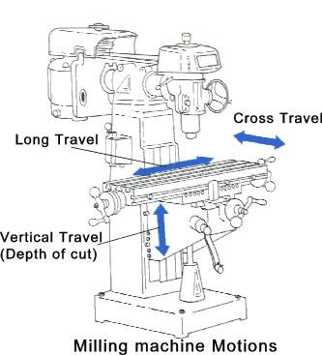

**Milling Machine**

Milling is a machining operation in which a workpart is fed past a rotating cylindrical tool with multiple cutting edges). (In rare cases, a tool with one cutting edge, called a fly-cutter, is used). The axis of rotation of the cutting tool is perpendicular to the direction of feed. This orientation between the tool axis and the feed direction is one of the features that distinguish milling from drilling.

**TYPES OF MILLING OPERATIONS**

There are two basic types of milling operations

(1) Peripheral

(2) Face milling.

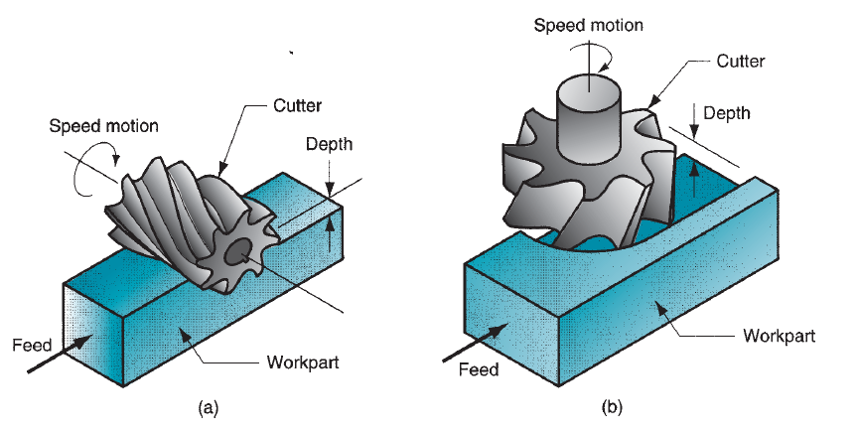

Fig: (a) Peripheral or plain milling (b) Face milling

**Peripheral Milling**

Peripheral Milling In peripheral milling, also called plain milling, the axis of the tool isparallel to the surface being machined, and the operation is performed by cutting edgeson the outside periphery of the cutter. Several types of peripheral milling are

1. **slab milling** ,slab milling the basic form of peripheral milling in which the cutter

Width extends beyond the workpiece on both sides

(**b)** **slotting,** also called slot milling, in which the width of the cutter is less than the workpiece width, creating a slot in the Work when the cutter is very thin, this operation can be used to mill narrow slots or cut a workpart in two, called saw milling

(**c) side milling**, in which the cutter machines the side of the workpiece

(**d) straddle milling,** the same as side milling, only cutting takes place on both sides of the work; and form milling, in which the milling teeth have a

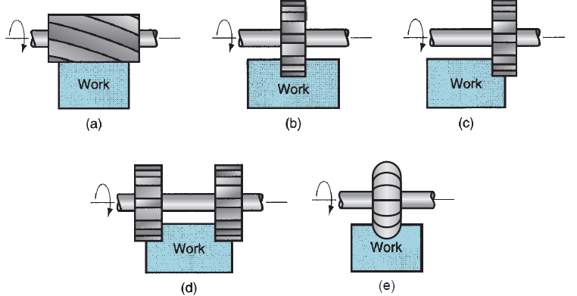\

**Face Milling**

In face milling, the axis of the cutter is perpendicular to the surface being milled, and machining is performed by cutting edges on both the end and outside periphery of the cutter.

**(a) conventional face milling,** in which the diameter of the cutter is greater than the workpart width, so the cutter overhangs the work on both sides.

(**b) partial face milling**, where the cutter overhangs the work on only one side

**(c) end milling**, inwhich the cutter diameter is less than the work width, so a slot is cut into the part

(**d) profile milling,** a form of end milling in which the outside periphery of a flat part is cut

**(e) pocket milling**, another form of end milling used to mill shallow pockets into flat parts

**(f) surface contouring,** in which a ball-nose cutter (rather than square-end cutter) is fed back and forth across the work along a curvilinear path at close intervals to create a three-dimensional surface form

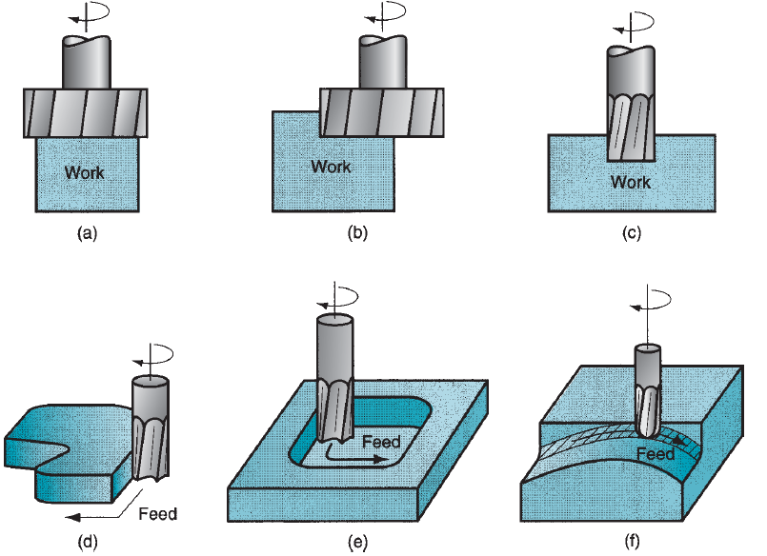

**Procedure**

* Give one complete rotation longitudinal lever and note time
* Give depth of cut to in vertical axis
* Calculate feed rate
* Calculate actucal machining time for simple facing time

**Observations and calculations**

Length of Workpiece=L=

Width of Workpiece=W=

No. of Teeth=nt =

Approach and over travel lengths=Lc=Lo+La=

Diameter of tool=D=

|  |  |  |  |  |  |
| --- | --- | --- | --- | --- | --- |
| Sr.No | RPM of tool(N) | Cutting speed=C.S= $π$ DN | Feed Rate  Fr=FxntxN | Machining time(th)  =L+LC\Fr | Machining time(actual) |
|  | mm\mint | mm\mint | mint | mint |
| 1. |  |  |  |  |  |
| 2. |  |  |  |  |  |

**Questions**

Differentiate between face milling and peripheral milling?

______________________________________________________________________________________________________________________________________________________

Write about different operations related to face milling?

________________________________________________________________________________________________________________________________

How to differentiate between up and down milling operations?

________________________________________________________________________________________________________________________________________________________________________________________________

Write about the operations related to peripheral milling?

_________________________________________________________________________________________________________________________________________________________________________________________________________________________________

**Comments:**

________________________________________________________________________________________________________________________________________________________________________________________________________________________________________________________________________________________________________________________________